Author Guidelines for the short paper [Title: two lines, 180 characters maximum]

First A. Author ¹ (main author’s first name + surname), Second B. Author ² (1st co-author’s first name + surname) and Third C. Author ³ (2nd co-author’s first name + surname)

Correspondence
Dr. Ramesh
ABCD University
Department of civil Engineering
Address
Email: aaa@uxy.edu

¹ Affiliation, Town, Country, E-mail
2 Affiliation, Town, Country, E-mail

Abstract
[Abstract: 1300 characters maximum] This document presents the information and Word instructions required to prepare a paper to be included in the proceedings of the Indian Structural Steel Conference (ISSC 2027). The paper must be written in English, using MS-Word. The files containing the styles for preparing the paper in MS-Word can be downloaded from the Conference Web Page at https://issc2027.civil.iith.ac.in/
Keywords: Article, Science, Know-How, e-only, PDF [up to 6 keywords, separated by commas]

- INTRODUCTION
The paper must be written in English, centered in size A4 pages with 2.5cm margins. Moreover, it cannot exceed 6 to 7 pages in length and 20 Mb in size (MS-Word file). The paper can be written using the template file available for download in the Conference Web Site for MS-Word (.docx file extension). In this template files, text styles are available for each particular part of the document (paper title, abstract, title sections, normal text, legends, etc.), providing the convenient font type, alignment, space between lines, etc. The direct use of these text styles will make writing the paper easier.

The author must send the MS-Word file containing the paper to the Conference secretariat no later than end date of submission deadline. Respected authors and co-authors get the confirmation mail after the submission with a paper ID (e.g., “ISSC27-XXX”). Papers can only be accepted on the understanding that one of the authors shall register for the conference and will be present the paper at the Conference. The full shall be submitted to the form given in the submission page of the conference website: https://issc2027.civil.iith.ac.in/

- TITLE, AUTHORS, AFFILIATION, KEYWORDS AND ABSTRACT
All Font style should be in Times New Roman and the page margin should be 2.5 cm all round with single line spacing. The first page includes the paper title, the author names and affiliations, up to 6 keywords and an abstract of the paper that must not exceed 12 lines. The title, author names, affiliations, keywords and abstract must be separated by 14 pt vertical spaces. Different affiliations must be separated by 6 pt vertical spaces.

2.1 Title
The first line of the title starts 30 pt below the top edge of the text area. The title must be centered and written in uppercase using bold Times New Roman font with size 17.

2.2 Authors
The author names must include the first name, middle initials and the last name. These must be centered and written in Times New Roman font with size 11. The author names must be located 14 pt below the last title line.

2.3 Affiliations
The author affiliations must be centered, written in Times New Roman font with size 10 and located 14 pt below the author names. The various author affiliations must be separated by 6 pt vertical spaces. However, different lines corresponding to the same affiliation are single-spaced. If various authors share the same affiliation, their e-mail addresses should be written sequentially.

2.4 Keywords
Up to 6 keywords must be provided, separated by semi-colons. These keywords are written in Times New Roman font, size 10, in justified lines and using “exactly 12 pt” spacing. The word Keywords:, written in bold Times New Roman font with size 11, must start the first line. The keywords must be spaced from the last line of the affiliations by a 14 pt vertical space.

2.5 Abstract
The typeface used for the abstract is an italic Times New Roman font with size 11. The word Abstract., written in bold Times New Roman font with size 11, must appear in the beginning of the first line. The abstract text is justified with “exactly 13 pt” line spacing and written 14 pt below the last line of the keywords, as shown in the first page of this template. The abstract of the paper must not exceed 12 lines.

3 SECTIONS

3.1 Main sections
The main section titles must be left aligned and written with uppercase bold Times New Roman font with size 11. An 18 pt space before and a 6 pt space after the section title must be specified.

3.2 Subsections
The subsection titles must be written left aligned, with a bold Times New Roman font with size 11. Only the first letter of the subsection title is uppercase, as all the others are lowercase. Spaces of 12 pt before and 6 pt after the subsection title must be specified − when a subsection title follows immediately a section title (as in subsection 4.1 of this template), the vertical distance between the two titles should be of only 6 pt.

3.2.1 Sub-subsections
The sub-subsection titles must be written left aligned, with a regular Times New Roman font, with size 11. Only the first letter of the sub-subsection title is uppercase, as all the others are lowercase. Spaces of 8 pt before and 4 pt after the sub-subsection title must be specified.

3.2.2 Footnotes
Footnotes can be included in the paper. They should be written with a regular Times New Roman font, size 9, in “exactly 10.5 pt” line spacing.

4 HEADERS
As shown in these instructions, the title page has a header with the name, venue and date of the Conference written in Times New Roman font, size 8 and centered aligned. All the other pages will have in the header the author(s) names, centered and written in Times New Roman font with size 9. For two authors, use First A. Author and Second B. Author. For more authors, use First A. Author et al... Please, do not alter the title page header and make sure that you comply with the headers of the other pages.

5 TEXT
The text must be typed in a single column, with “exactly 14 pt” line spacing, justified and employing Times New Roman font with size 11. The first line of each paragraph must be indented by 0.5cm and a 4 pt space should be specified between consecutive paragraphs.

6 PAGE NUMBERS
The authors should include page numbers in the bottom of the pages and centered, employing a Times New Roman font with size 9. No number should be included in the first page.

7 FIGURES
Figures should be included within the text and all of them should be referred in the text. The figures should be inserted in the text in a “camera-ready” form (the page size will remain unaltered), numbered consecutively and each of them must be immediately followed by the corresponding caption. The figures should be included in “single-space” paragraphs. The captions are centered and written using a Times New Roman font with size 11 and in “single-spaced” lines, as indicated in figure 1 above. Between the text and a figure, an “exactly 10 pt” space blank line must be included. The vertical distance between each figure and its caption must be 4 pt, between a figure caption and the text, an “exactly 10 pt” space blank line must be included. The figures should be included in the text as close as possible to the first time they are referred in the text.

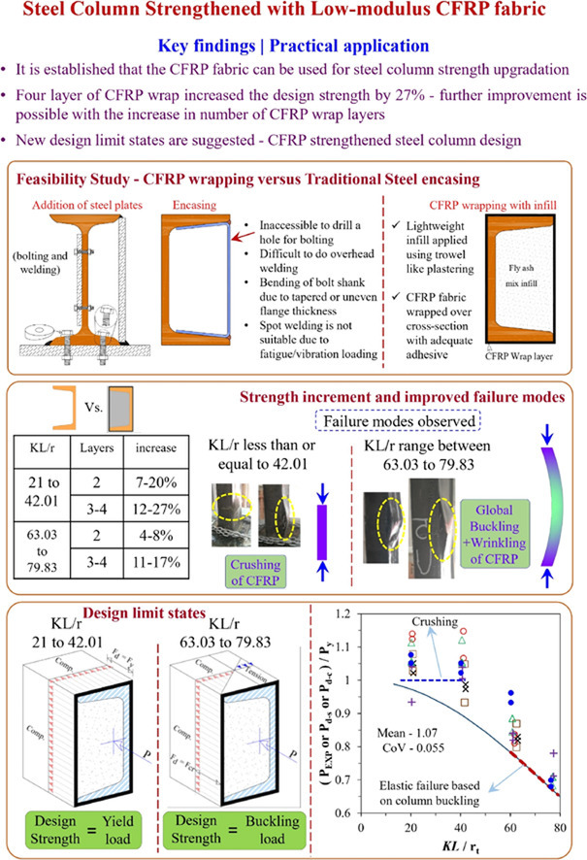
Figure 1: Example of a figure.

8 EQUATIONS
The equations must be centered and “exactly 10 pt” space blank lines must be included to separate the text from the first equation, consecutive equations and the last equation from the text. Please, write the equations using (i) letters/symbols in italic with font size 11 and (ii) the numbers in normal style also with font size 11. When letters/symbols and/or numbers are subscripts, they retain the style but the font size is reduced to 8. The equations must be numbered sequentially using Arabic characters included in parenthesis and right aligned. The following is an example of two consecutive single-line equations written according to the specifications: If the wants to use the non-standard fonts, please make sure that they appear correctly in the MS-WORD file.

(1)

9 TABLES
Tables should be prepared with the format shown below and included within the text. All of them should be referred in the text. The tables should be numbered consecutively and each of them must be immediately preceded by the corresponding caption. The captions are centered and written using a Times New Roman font with size 11 and in “single-spaced” lines, as indicated in table 1 below.

Table 1: Example of a table.
Column X | Column Y | Column Z
C1X | C1Y | C1Z
C2X | C2Y | C2Z
C3X | C3Y | C3Z
C4X | C4Y | C4Z
C5X | C5Y | C5Z

Between the text and a table caption, an “exactly 10 pt” space blank line must be included. The distance between each table and its caption must be 4 pt. Between a table and the text, an “exactly 10 pt” space blank line must be included.

10 CONCLUSIONs
Authors should be aware that each page will appear in the Conference Proceedings exactly as is shown in the MS-WORD file they send to the ISSC 2027 Organising Committee. Therefore, it is essential that these instructions be strictly followed. Authors are strongly advised to use this template file to write their papers, since it was prepared following the above instructions.

REFERENCES
The reference should be as per “Harvard style” from google scholar and must be aligned in an alphabetical order.

- Selvaraj, S. and Madhavan, M., 2019. Improvements in AISI design methods for gypsum-sheathed cold-formed steel wall panels subjected to bending. Journal of Structural Engineering, 145(2), p.04018243.
- Sirigiri, H. and Madhavan, M.M., 2025. Experimental study on bolted apex connector for single-channel CFS portal frames. Journal of Structural Engineering, 151(7), p.04025092.
- Panchamoorthy, K.S. and Madhavan, M.M., 2025. Experimental study of screw connections in plywood-sheathed CFS wall panels subjected to in-plane shear loading. Journal of Structural Engineering, 151(5), p.04025032.
- Mallepogu, N. and Madhavan, M., 2024. Ultimate shear capacity of the cold-formed steel torsionally restrained beam-to-column moment connection with a three-bolted clip angle and flange cleat. Journal of Structural Engineering, 150(6), p.04024045.
- Panditaray, A.K., Naik, B., Madhavan, M.M. and Muvvala, G., 2026. An Investigation on Residual Stress Distribution in Cold-Formed Steel Channel Sections. Journal of Structural Engineering, 152(2), p.04025277.

Nevertheless, footnotes should be avoided as much as possible.

